**Immersive Reader Quick Guide Directions**

1. 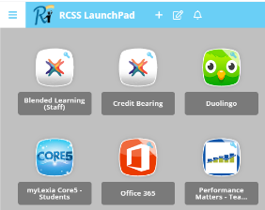Log Into **RCSS Launchpad** with your Username and Password
2. Click on the **orange Office 365 icon**

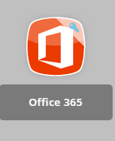

1. 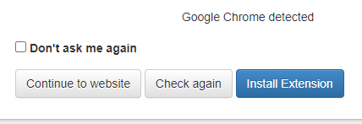Press **Continue to Website** to go to Office 365 Home Page
2. Click on the **Microsoft Word blue icon**





1. 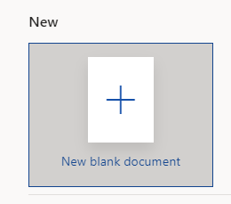Select **New Blank Document**
2. Click on the **View** Tab



1. **Type your words** into the document **OR** select **Copy (CTRL + C)** to add words from the story or original text.
2. Right click and select **Paste (CTRL + V)** to place the words you copied into Word

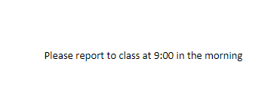

1. Select the **Immersive Reader** tab



1. Press the **Play Button** to listen to the words you typed

**Icon Features**



**Play Button**

* Plays message in document back to you
* Highlight text as it reads

**Voice Settings Button**

* Change the speed of the voice playback
* Change the voice selection

**Text Preference Button**

* Change the size of the text
* Increase the spacing of the text
* Change the text font
* Add color themes to the font

**Grammar Options Button**

* Distinguish syllables in your message
* Distinguish the part of speech of a word

**Reading Preferences Button**

* Show a certain line of text when reading
* Picture dictionary
* Translator